# DAD 220 Module Three Lab Template

## Overview

To complete this lab, go to your Codio virtual lab environment and start a new terminal session. Once there, **connect to the employee information you entered in the Module Two lab**. Then perform the steps below to complete the activity. Manually enter any commands you are asked to write.

At the end of each step in the activity, replace bracketed text with a screenshot, brief explanation, or both, as indicated. Size each screenshot and its explanation to fit about one-quarter of the page with the description written below the screenshot. Review the Template Screenshot Example linked in the guidelines and rubric for this assignment to see an example of how screenshots for your assignment should look.

## Create Joins Between Tables

1. **Update the name of the Branches table** that you created in the previous lab to say "Department".
   1. Use an ALTER statement to RENAME the Branches table "Department".
   2. Capture these outputs in a screenshot to validate that you successfully completed this step.

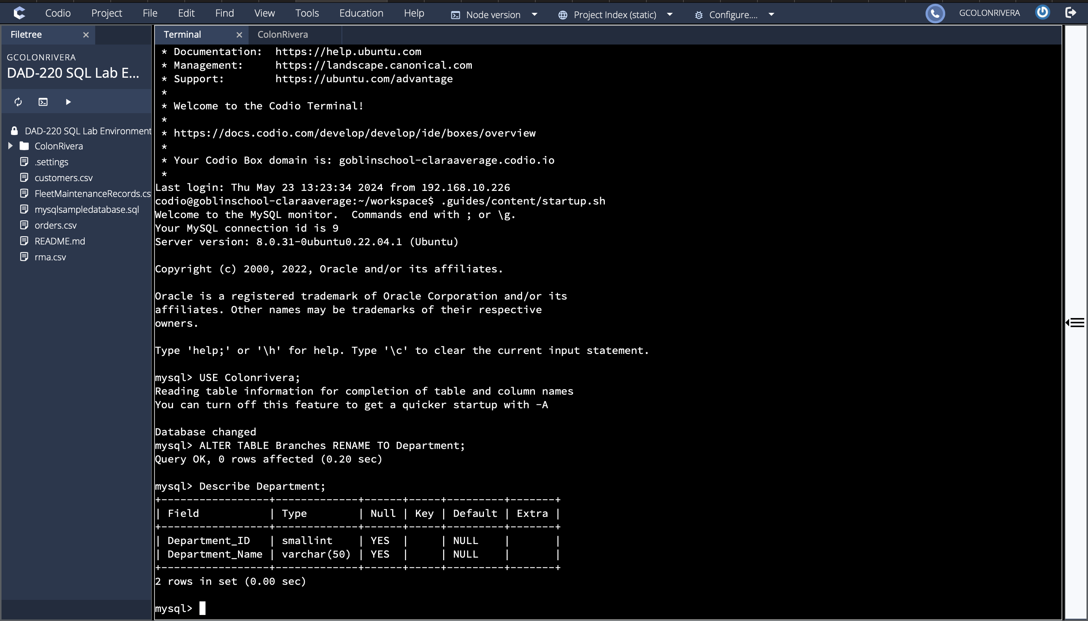

1. **Insert fields to the Department table** so that joins can be performed on tables.
   1. INSERT INTO Department VALUES

(1, 'Accounting'),   
(2, 'Human Resources'),   
(3, 'Information Systems'),   
(4, 'Marketing');

* 1. Write a SELECT statement for this table to prove this step and validate that it ran correctly with a screenshot.

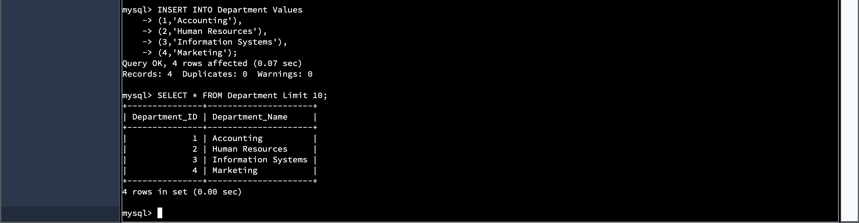

1. **Perform joins between the Department and Employee tables** **and show results** for how many employees work in each of the four departments. This action will only provide information on the records that are already there.
   1. Department 1 = Accounting
      1. Command: SELECT First_Name, Last_Name, Department.Department_Name FROM Employee INNER JOIN Department ON Employee.Department_ID = Department.Department_ID WHERE Employee.Department_ID = 1;
   2. Using SELECT statements similar to that above, **perform joins to produce results** for the following tables:
      1. Department 2 = Human Resources
      2. Department 3 = Information Systems
      3. Department 4 = Marketing
   3. Capture the results of these joins and validate your work by providing a screenshot. You should have the same number of records as you do employees.

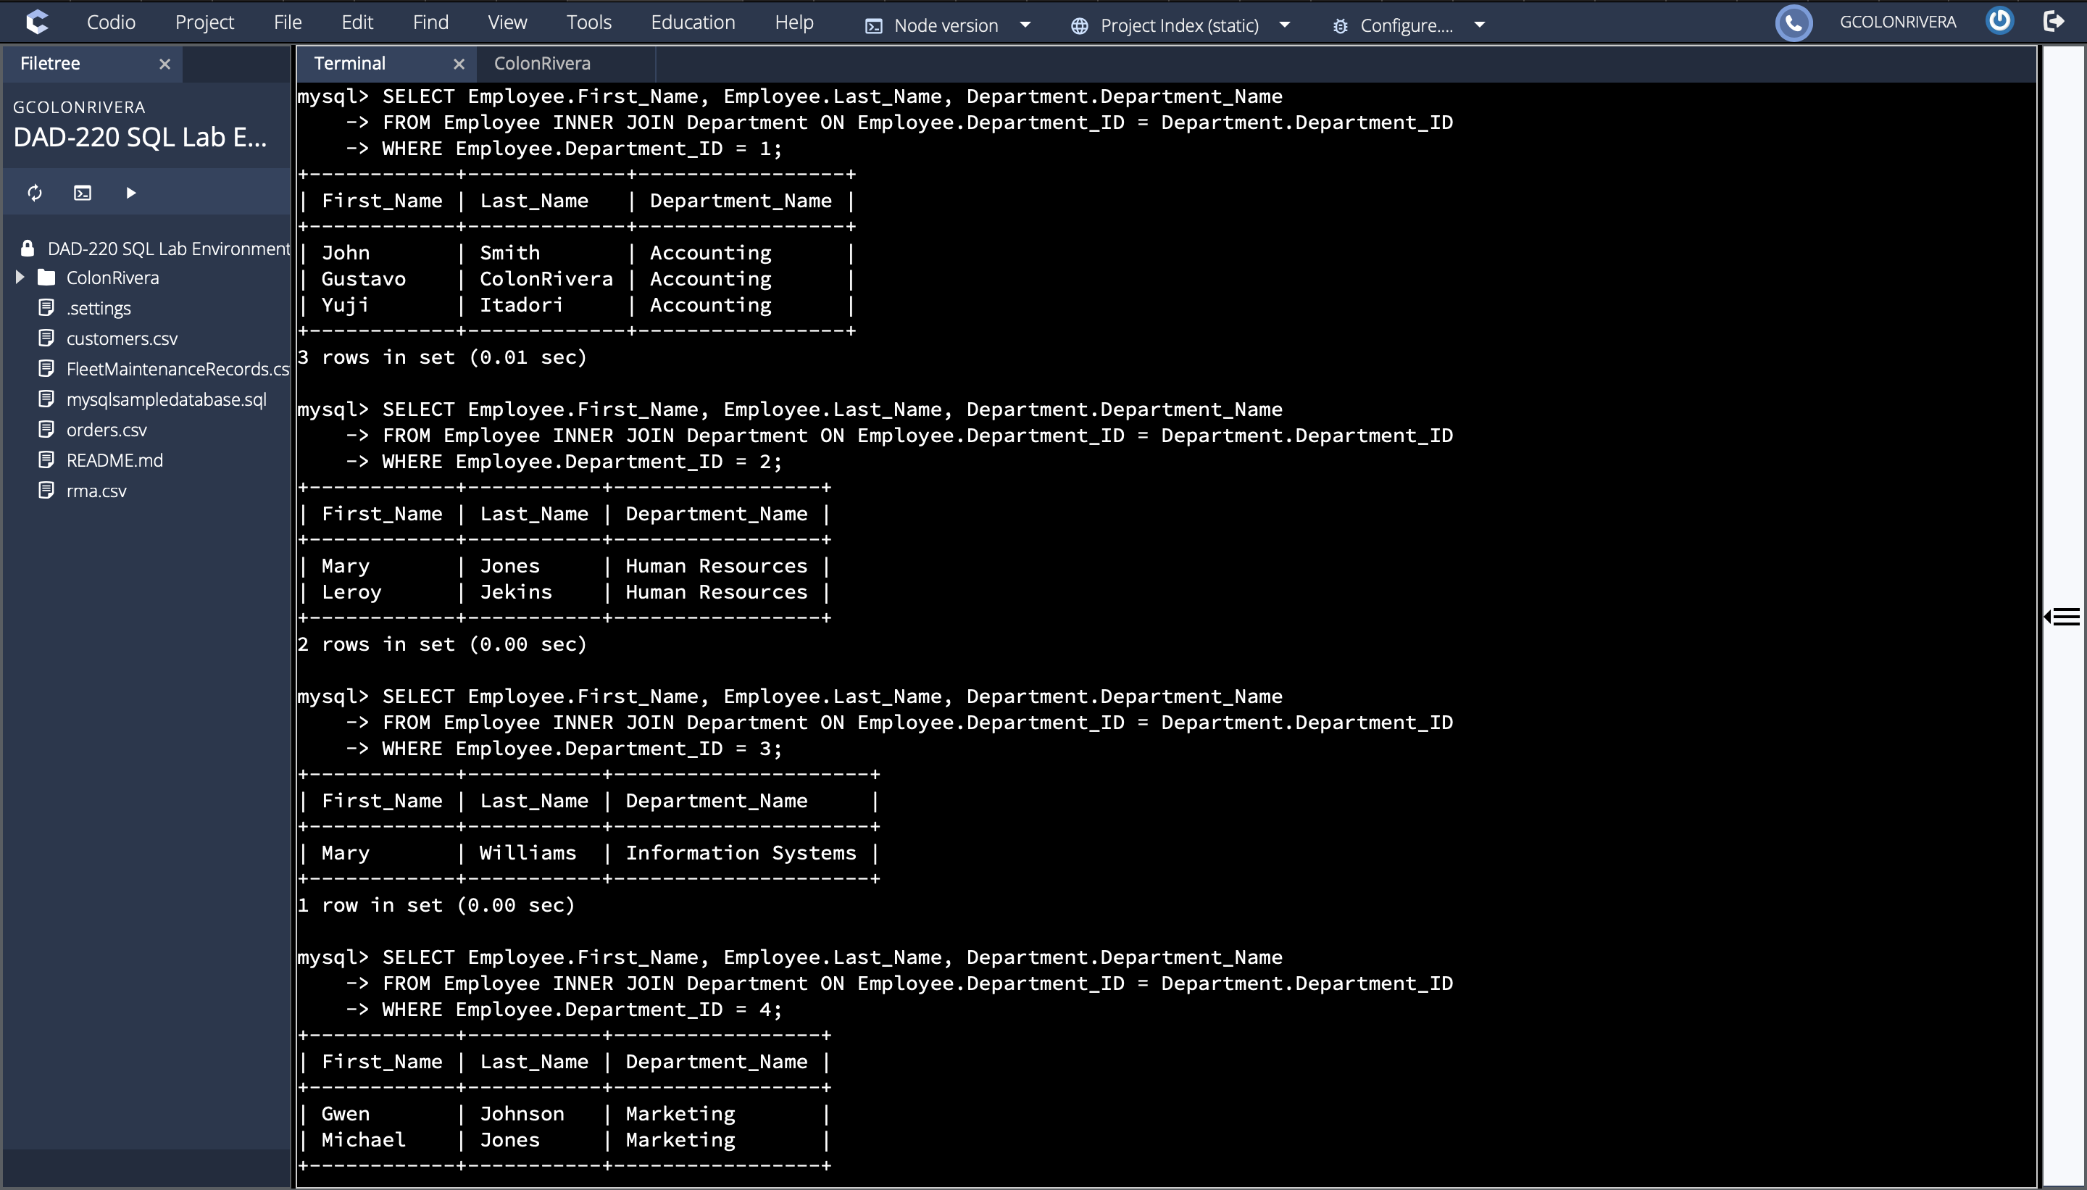

1. **Populate the Employee table with**information for 10 **new employees**.
   1. Give the employees unique names and include attributes for all necessary fields. Note: Reference attributes from the lab in Module Two. Department ID values must be between 1 and 4.

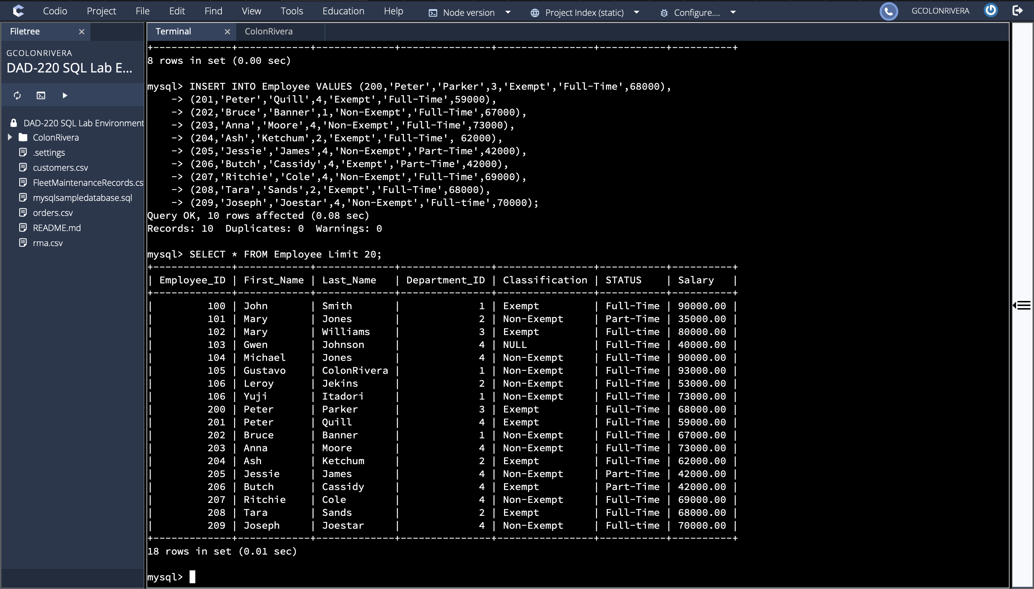

1. **Perform a join across the Employee and Department tables** for each of the four departments. New and existing records should be displayed in the results.
   1. Take a screenshot to capture the updated results that the Employee and Department joins show and validate that they have run correctly. You should have the same number of records as you do employees.

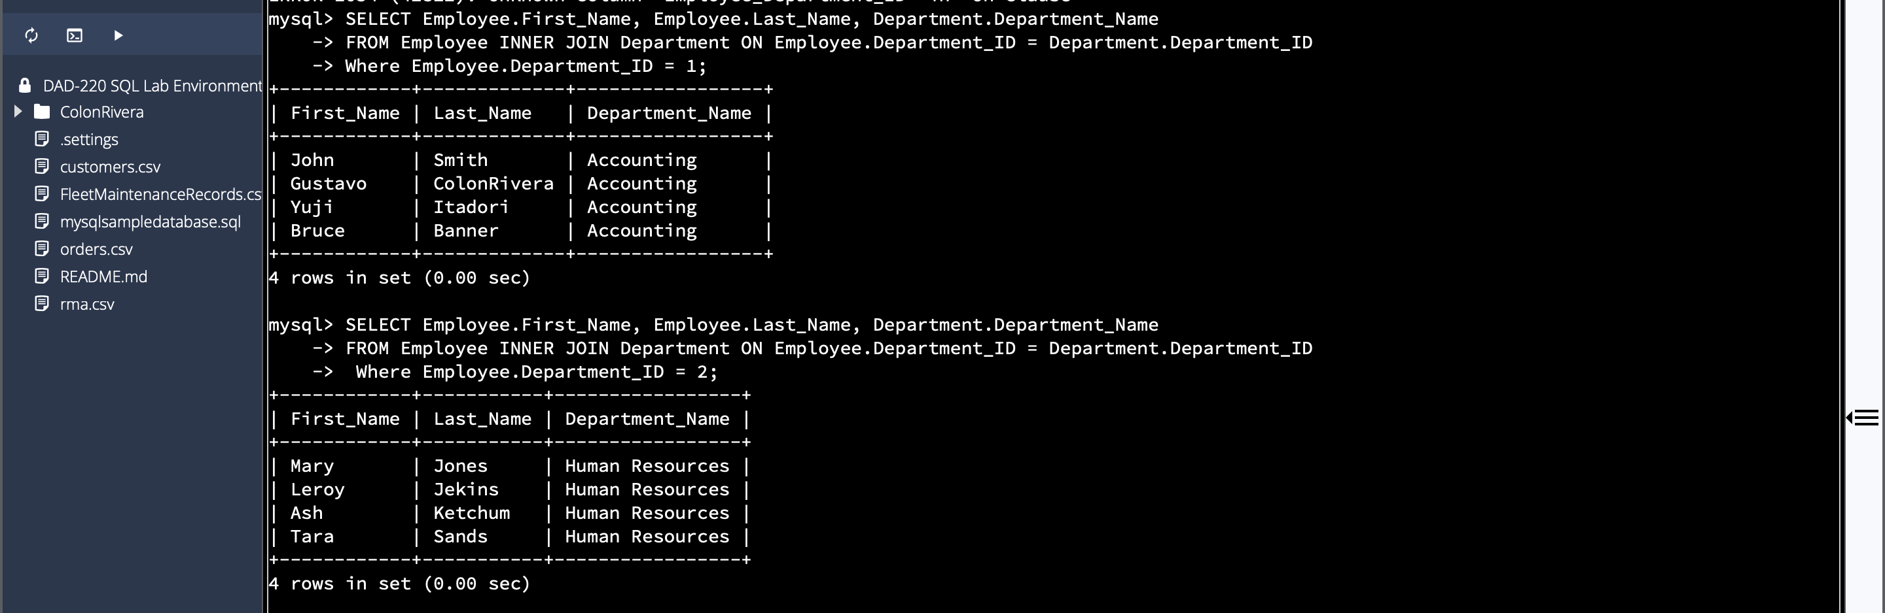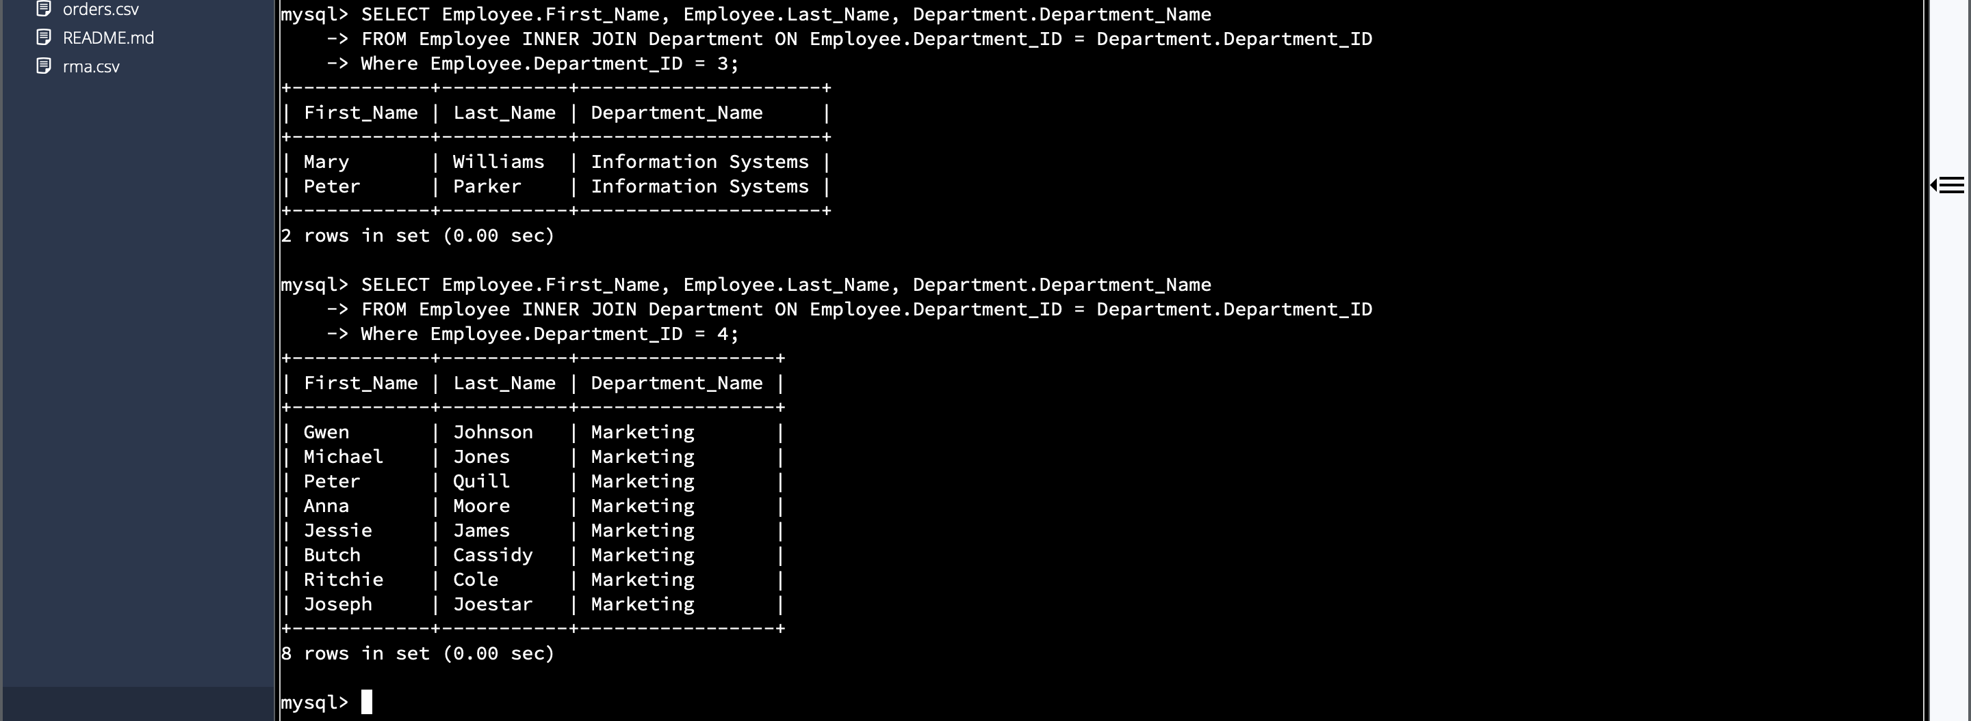

1. **Identify the resultant outputs** of the commands you wrote and answer the following question:
   1. How many records are returned for employees in each department?

1-Accounting has 4 employees

2-Human resources has 4 employees

3-Information Systems has 2 employees

4-Marketing has 8 employees

1. **Create a CSV file** that contains only the records of employees in Human Resources and Information Systems. If you run this query multiple times, be sure to use a different file name each time. MySQL will not overwrite an existing file.
   1. Enter the command listed below.
      1. Command: select First_Name, Last_Name, Department.Department_Name from Employee inner join Department on Employee.Department_ID = Department.Department_ID where Employee.Department_ID = 3 OR Employee.Department_ID = 2 into outfile'/home/codio/workspace/HRandIS-Employees.csv' FIELDS TERMINATED BY',' LINES TERMINATED BY '\r\n';
   2. Print the file output to the screen.
      1. In order to print your screen, start by refreshing your browser.
      2. Type the word "quit" after your MySQL prompt. Then press **Enter** to exit to the Linux shell. Do not exit the virtual lab environment.
      3. Print the output of your file to the screen using these steps:
         1. Type "pwd" and press **Enter**. Then type "ls" and press **Enter** again to list your files.
         2. Next, type "cat HRandIS-Employees.csv" and press **Enter**.
         3. Capture these outputs in a screenshot to validate that you successfully completed this step.

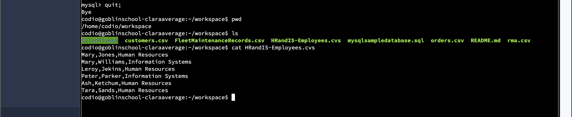

1. **Reflection:** Provide detailed insight on the prompts below. Explain your process and how and why your process worked. Write your responses to the questions below in paragraph form.

* 1. Process
     1. **Explain** how **the joins** you used in this assignment worked.

When using the joins in this assignment,  the system is told that we wanted to pull all

of the employees' first and last names from the Employee table who were associated with

a specific department number. We used the Department table to define which number was

associated with each employee. The system pulled the information from both tables and

created a new table based on the defined department number.

* + 1. **Describe** why the **commands** you used were able to retrieve the Department table when you selected the Department name.

The commands were able to retrieve the information because we identified the

Departments of the employees by assigning them a number in the Department table. We then used those numbers to link the employees in the Employee table to a department by using one of the numbers they were set as. When we linked them together using the commands, it used

that number to define the department and pulled from the Employee table and Department table to define the department.

* 1. File creation and extraction
     1. **Identify** how many **records** are in the file when you write the records of your query to a CSV file.

There are a total of 6 records in the CSV file.

* + 1. **Explain**, in detail, the process of **extracting data** to a flat file.

The process works by extracting the first and last names of the employees from the Employee table, and then the department and department names from the Department table. We then use the inner join and tell the system which department ID we want to extract by using the ID numbers we assigned in that table. Then we tell the system we want this information extracted into a CSV file. By doing this, it creates an individual report which makes it easier for us to review only the information we requested and leaves out all of the other information.